Python Worksheet #2

Tuples, Dictionaries, Functions, Recursion

Dr. Scott

CSI 500

Spring 2019

# Problem #1: Tuples

In the lectures, we discussed how to create and iterate over tuples. Use your Python skills to accomplish the following.

* Create a tuple named **months** that holds the names (or 3-character abbreviations) for the names of the months of the calendar year.
* Create another tuple called **days** that holds the number of days in each of these months (you may allow February to have 28 or 29 days depending on your preference for leap-years)
* Write a Python expression to iterate over these two tuples and create a new set of tuples, where each contains the name of the month, a comma, and the number days in the month (Hint: you may want to use the zip() function). Your output should look something like this.

('Jan', 31)

('Feb', 29)

('Mar', 31)

etc…

# Problem #2: Dictionaries

Continuing with our linguistic analysis example from the lecture, let's analyze some of the text from William Shakespeare's Sonnets. Go to the website: <http://www.folgerdigitaltexts.org/download/txt.html>

Scroll down to the bottom, and select "Shakespeare's Sonnets", at <http://www.folgerdigitaltexts.org/download/txt/Son.txt>

Download this text file to your computer. Open the file, and select your favorite sonnet. Cut and paste into the **text** variable we used in the class lectures when we analyzed Humpty Dumpty. Run the dictionary extractor, and identify which words are most commonly used in your selected Sonnet.

Create a listing of your results by iterating over the word frequency dictionary, showing the list of words and word frequencies. Did you find any unusual or archaic words?

# Problem #3: Mathematical Functions

Two widely used methods for measuring temperature are the Fahrenheit and Celsius scales. While both are interval scale systems, they have different origins and different scales. Use your Python mathematical function skills to write a a function that converts from Fahrenheit to Celsius, and a complementary function that converts from Celsius to Fahrenheit. Test your code using the values for the freezing point of water (0⁰ Celsius, 32⁰ Fahrenheit) and the boiling point of water (100⁰ Celsius, 212⁰ Fahrenheit). You may find the following diagram helpful as you work through this problem.

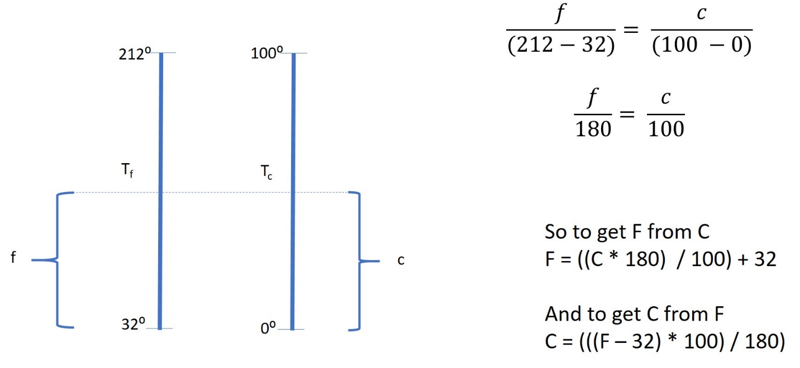

# Problem #4: Logical Functions

In lectures, we introduced how Python can support Boolean Algebra with logical operations such as AND, OR, and NOT. These are essential elements of digital logic which is widely used in electronics. Imagine that you are working as an electrical engineer at an integrated circuit manufacturer, and you need to develop software to test out a new chip design.

You have been assigned the following integrated circuit chip design. Develop a Python function that emulates the digital logic of this chip. Use your function to determine what the expected outputs on pins 5 and 6 will be given the specified inputs on pins 1, 2, 3, and 4 as shown in the data table below.

Note the logic key on the right: this indicates the symbols used for the chip layout.

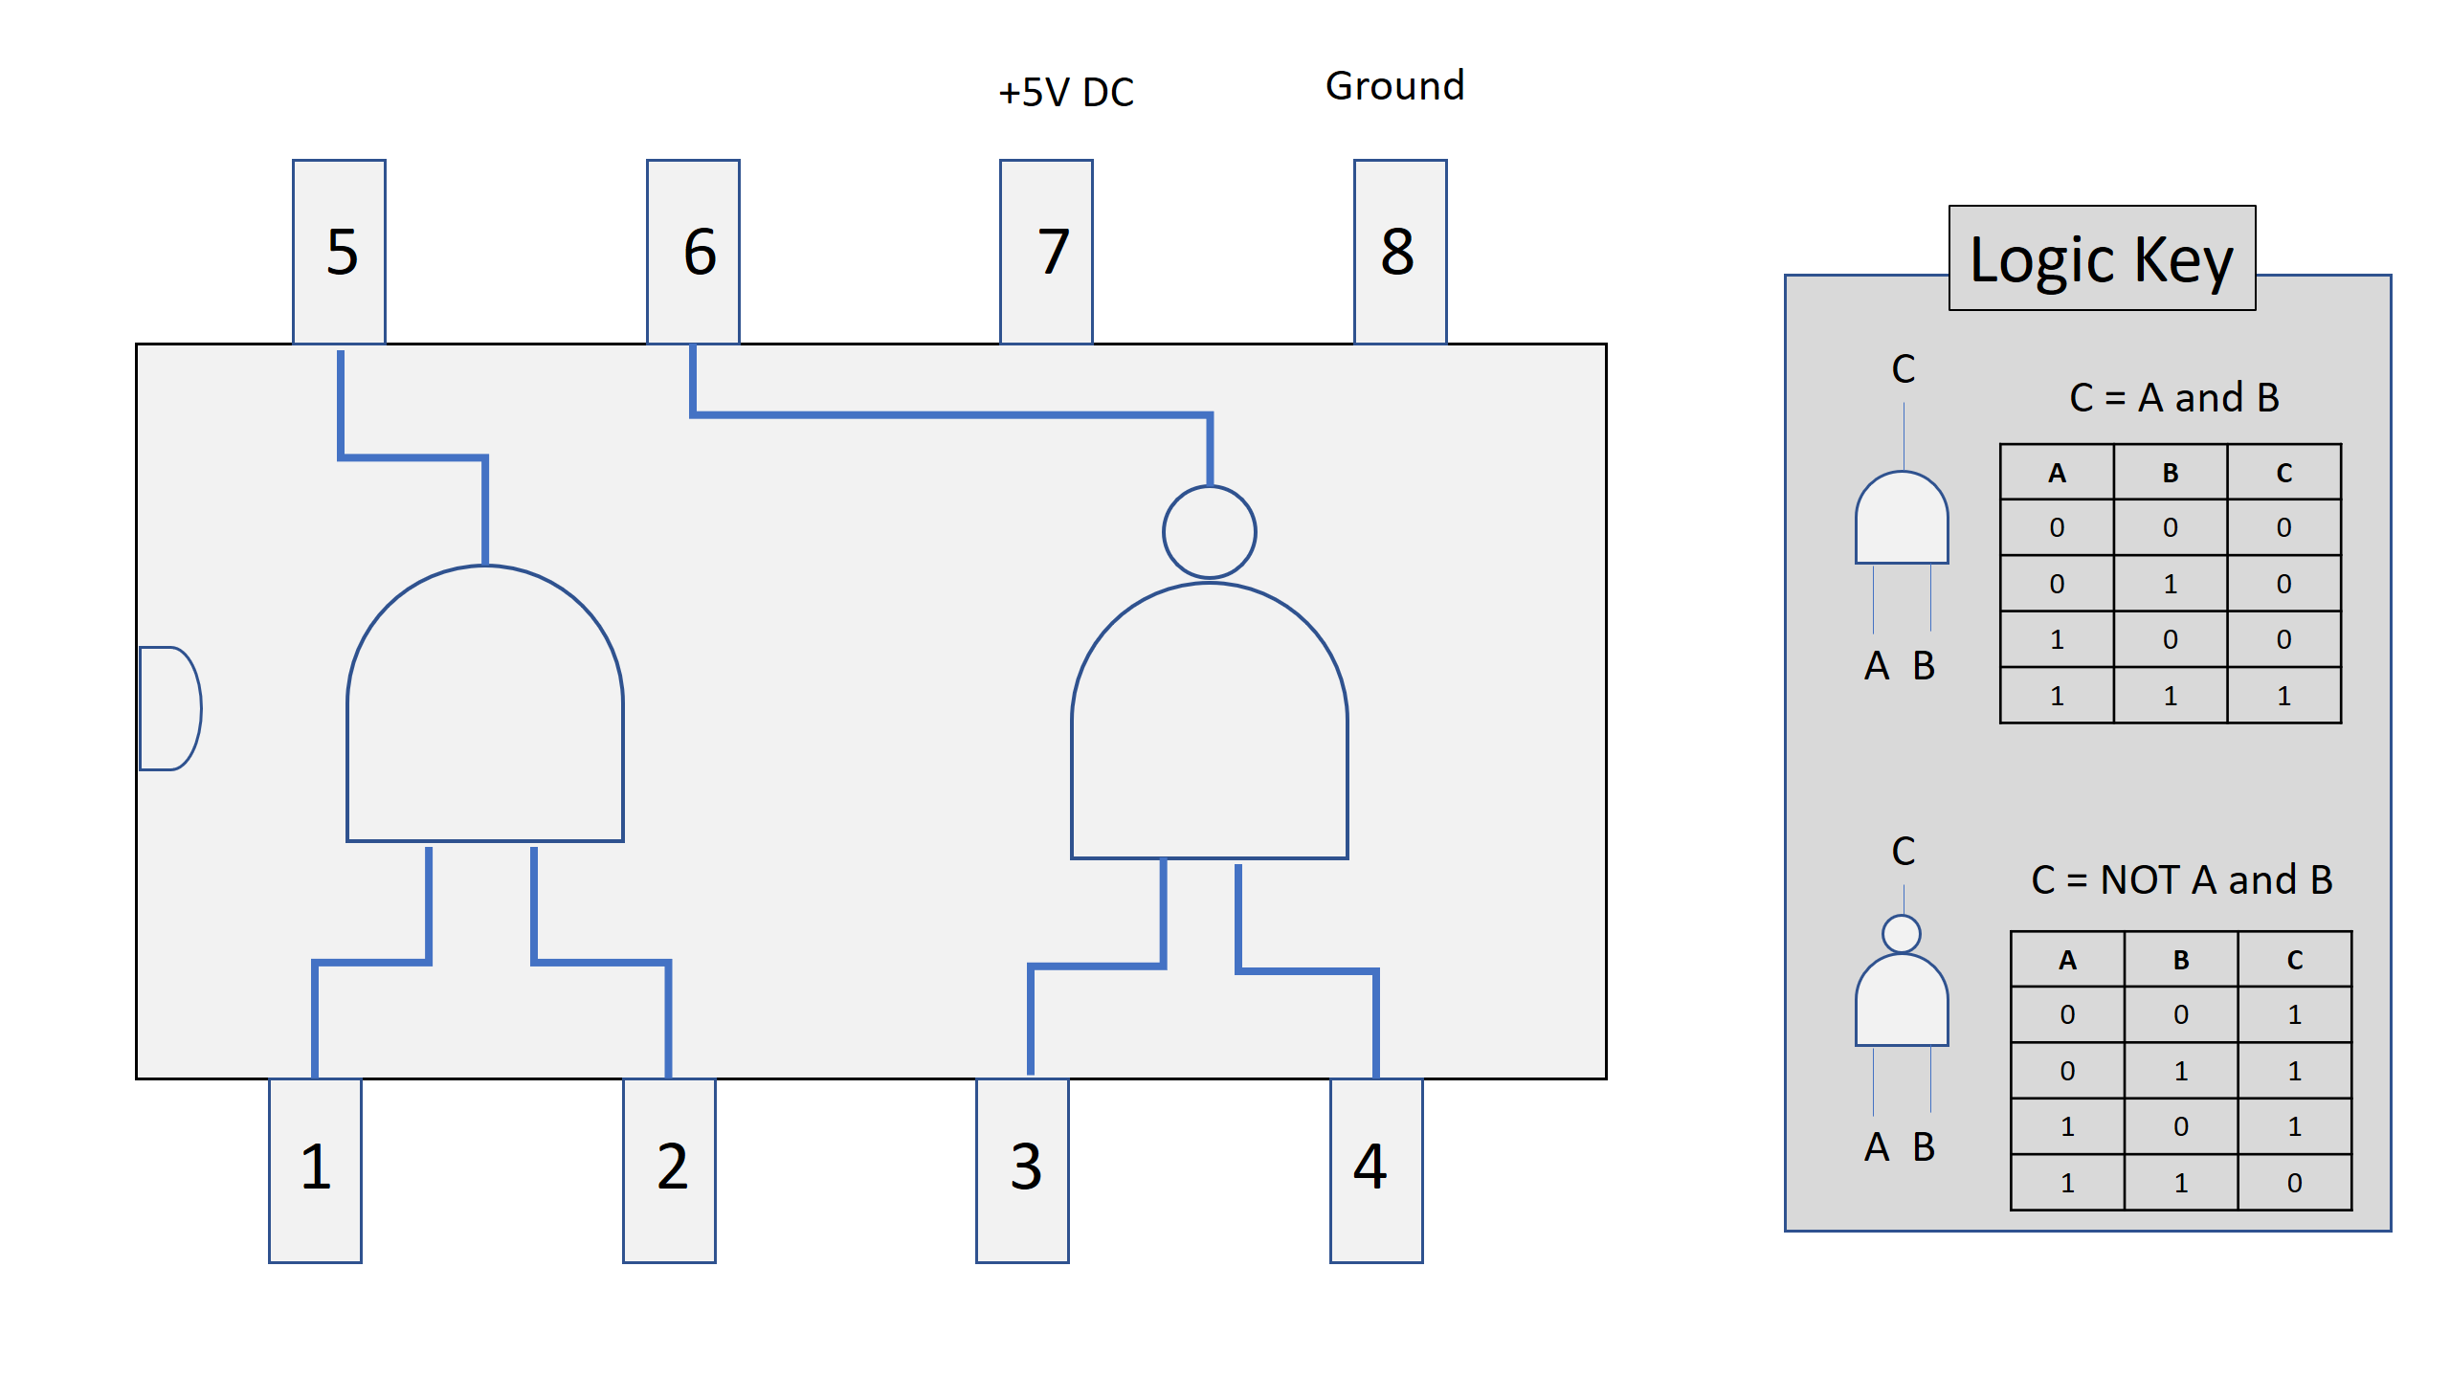

Use your Python function to compute the values for the outputs in Pin 5 and Pin 6 given the specified inputs for Pins 1 thru 4. You may ignore Pins 7 and 8 for this exercise.

|  |  |  |  |  |  |
| --- | --- | --- | --- | --- | --- |
| **Inputs** | | | | **Outputs** | |
| **Pin 1** | **Pin 2** | **Pin 3** | **Pin 4** | **Pin 5** | **Pin 6** |
| 0 | 0 | 0 | 0 |  |  |
| 0 | 1 | 0 | 1 |  |  |
| 1 | 0 | 1 | 0 |  |  |
| 1 | 1 | 1 | 1 |  |  |

# Problem #5: Recursion

Leonardo Fibonacci was an Italian medieval mathematician. In one of his writings, he posed a problem in which a farmer starts with a single pair of rabbits, who after one month produce another pair of rabbits. Each month, all the rabbits older than one month old produce more rabbits. This process continues, which not surprisingly produces a large number of rabbits in a relatively short period of time. More formally, the number of rabbits is given by the following expression, where Fibonacci(N) is the number of pairs of rabbits at time N.

Fibonacci( 0 ) = 1

Fibonacci( 1 ) = 1

Fibonacci( N ) = Fibonacci( N-1 ) + Fibonacci( N-2 )

Use your Python programming skills to develop a recursive function to compute the Fibonacci value. Test by writing Python expressions to print out the time period and the first 20 Fibonacci values. Your output should look something like this.

N Fibonacci(N)

0 1

1 1

2 2

3 3

4 5

etc.